Database Documentation

In this document information is written about the database that we used in our project. You can setup your own database and use this for the project.

First the Firebase setup.

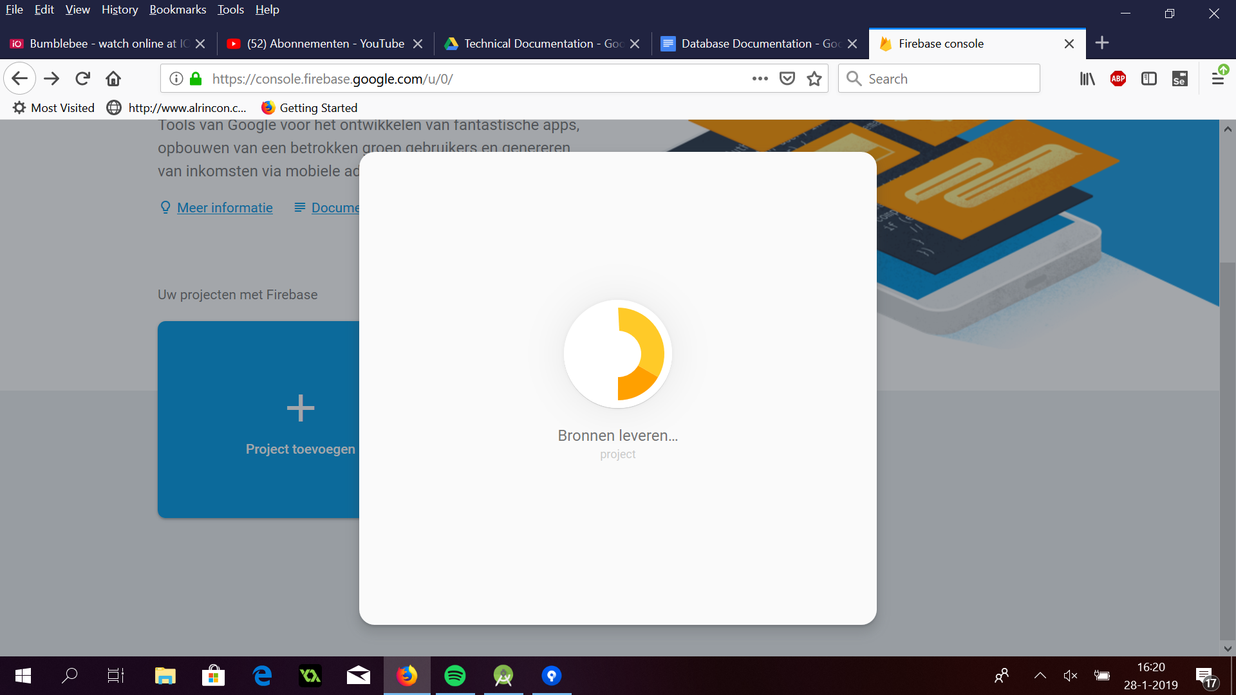
We had to first add our own Firebase project.

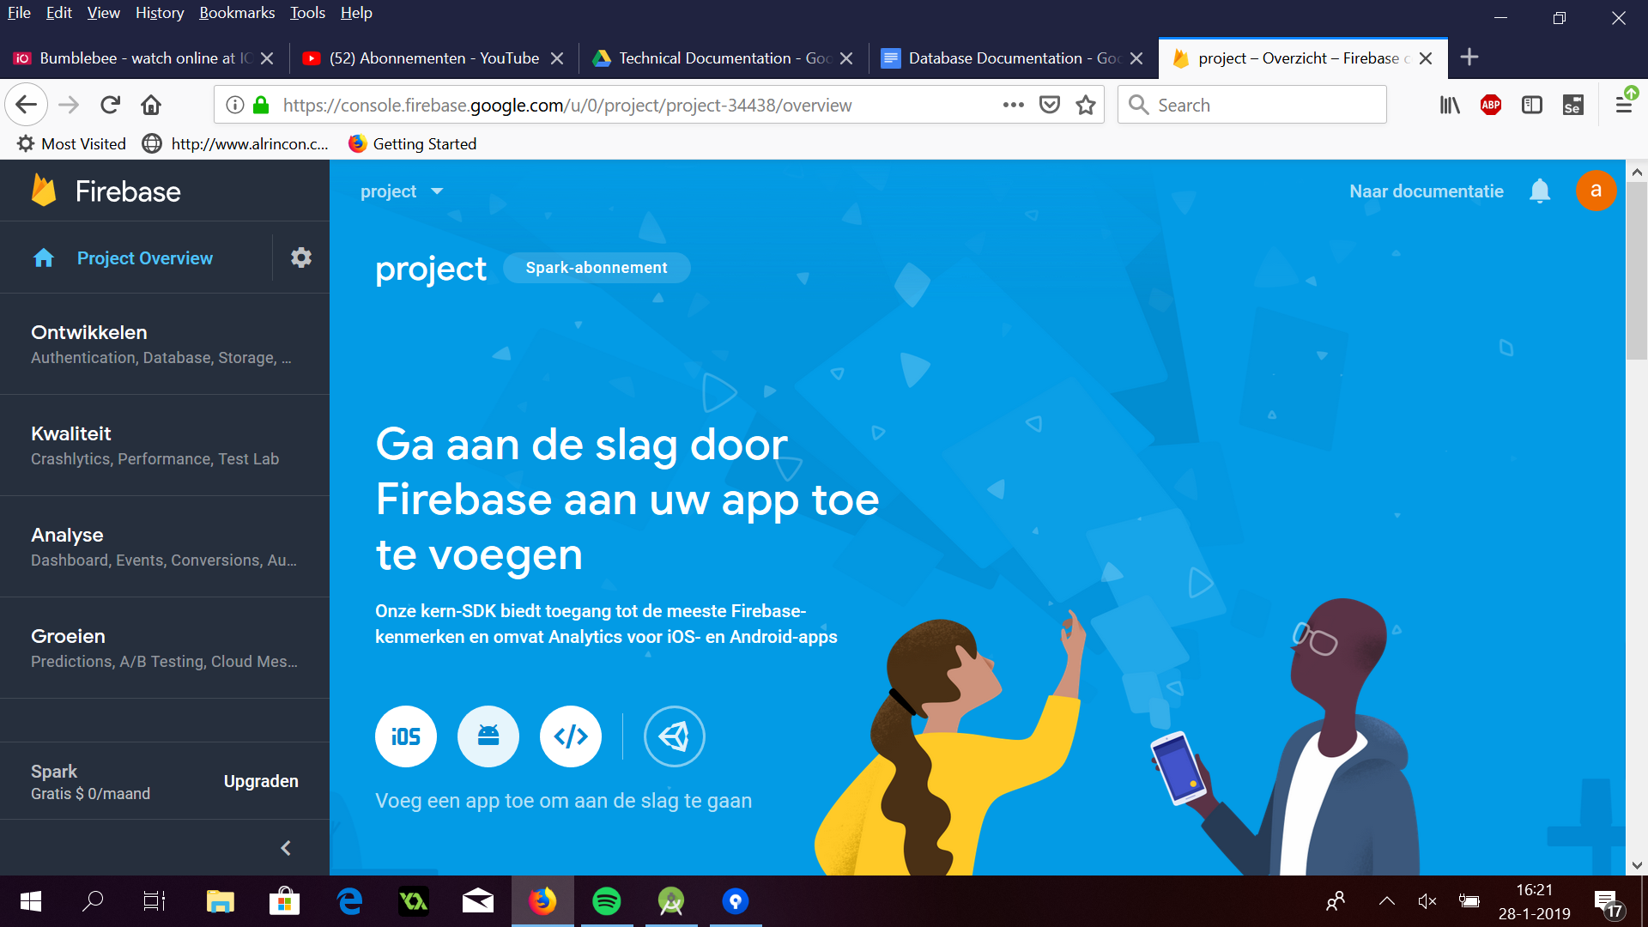
After we made our own Firebase project, this screen popped up and we could add our app.

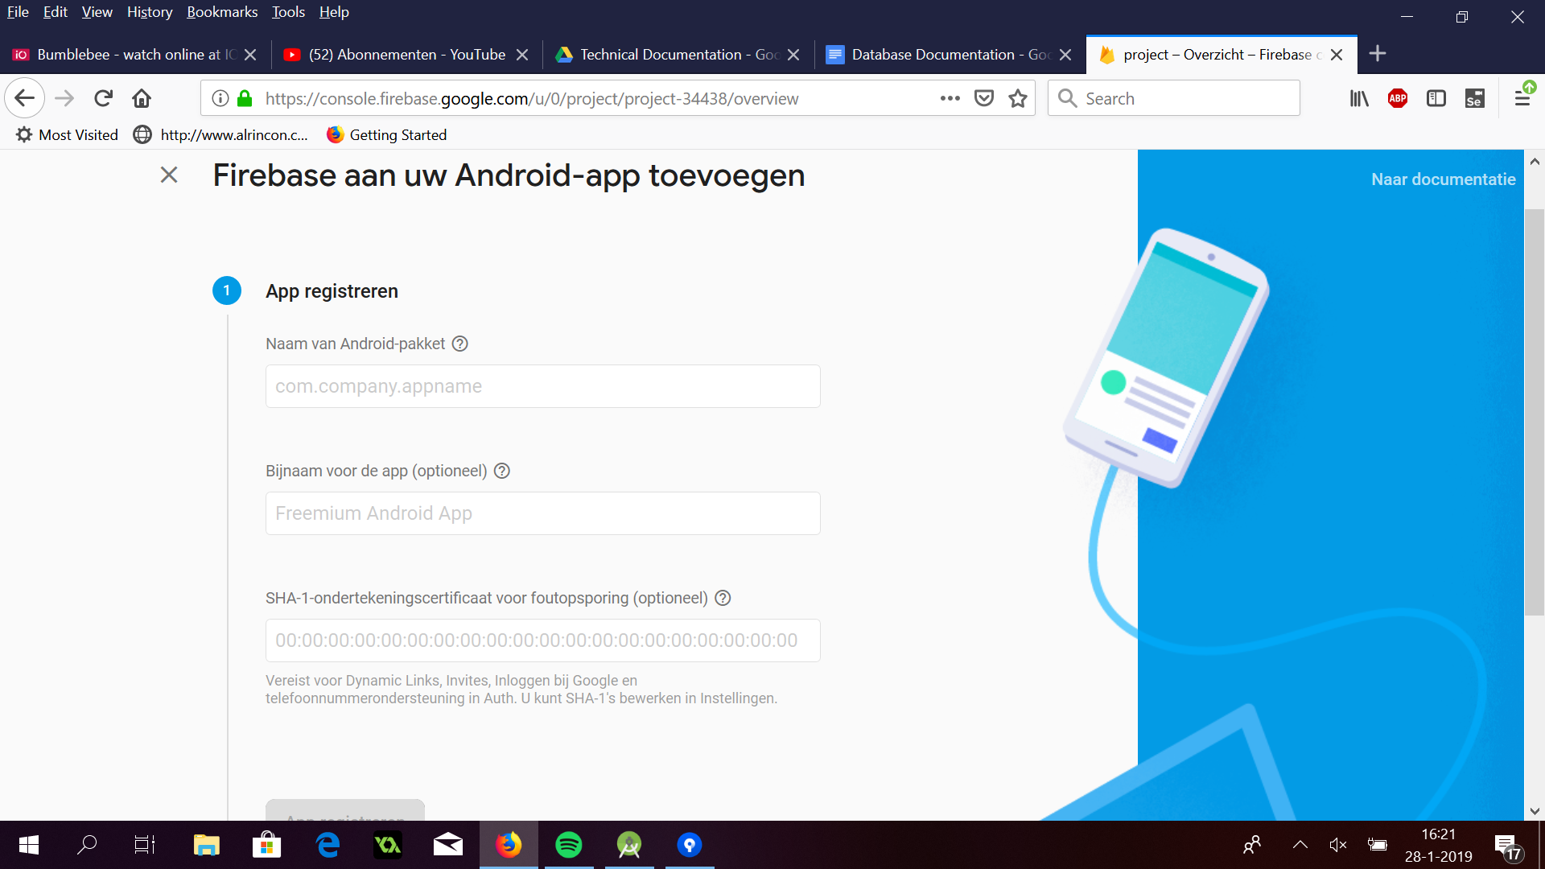
After we completed these steps we could successfully use Firebase in Android Studio.

We used Firebase to store the data from the Main Hub so that the app can pull the data out of it for real time information. In picture 1 you can see the layout we used for the project. Basically it consists of Pins and Plants. Pins will be further divided in all the pin numbers (ex. 4444, 7777 or 3746). Each Pin has different plants, every plant a stick in it and every stick its own data which it receives from the Main Hub. Each stick has the values Duration, Water, Light and Temperature. Duration stands for how long a plant will grow when having optimal conditions for water, light and temperature.

A pin can also be unverified or verified. If it is unverified, the pin is not used by someone else. If it is verified it means that someone else uses this pin. The pin equals the pin from the SIM card used in the Main Hub. Instead of a four digit number, it can be replaced with the puccode of the SIM card. If the user starts the app for the first time, it is asked for a pin number. If they fill in this number (ex. 4444), “verify” will be put to verified. This way, another user can’t use the same pin that you are using.

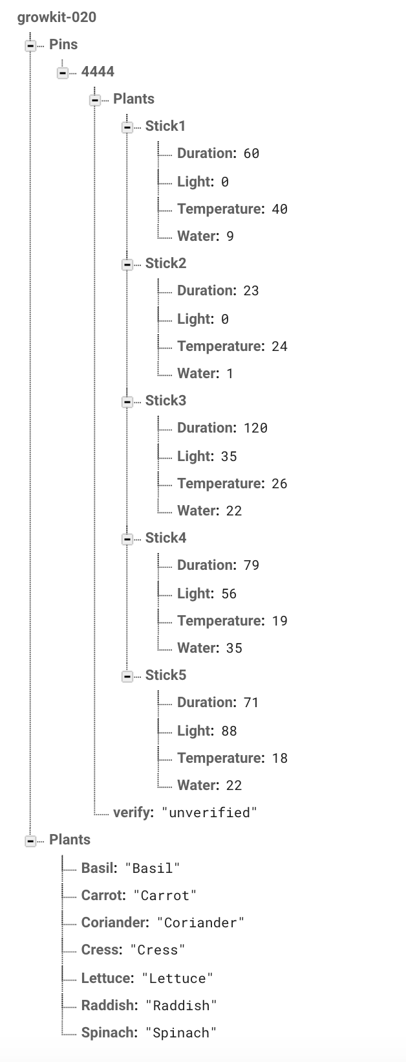 Picture 1

