List of all components used

Number | Name | Used for | Link
1 | Pycom GPY | Main Hub | https://docs.pycom.io/datasheets/development/gpy.html
2 | Pycom Expansion Board 3.0 | Main Hub | https://docs.pycom.io/datasheets/boards/expansion3
3 | WS2813 Ledstrip - 30 LED | Main Hub | https://www.kiwi-electronics.nl/ledstrips/digitale-rgb-ledstrip-ws2813-30-led-1m
4 | LTE-M Antenna | Main Hub | https://pycom.io/product/lte-m-antenna-kit/
4 | I2CSoilMoistureSensor | Stick | https://www.tindie.com/products/miceuz/i2c-soil-moisture-sensor/
5 | Adafruit Feather Huzzah | Stick | https://www.adafruit.com/product/2821
6 | Lithium Ion Battery - 1Ah | Stick | https://www.sparkfun.com/products/13813

Schematics
Below you can find all the schematics of the all the components listed above.

Pycom GPY

Picture 1

For a more detailed version of the Picture 1, click the following link:
https://pycom.io/wp-content/uploads/2018/08/gpy-pinout.pdf

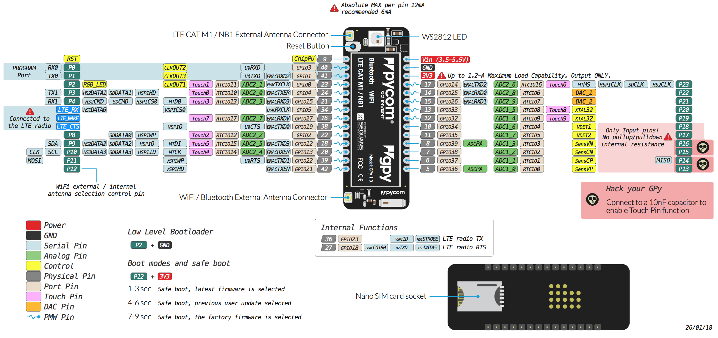
For the whole documentation of the Pycom GPY, click on the following link:
https://pycom.io/wp-content/uploads/2018/08/gpy-specsheet.pdf

Pycom Expansion Board 3.0
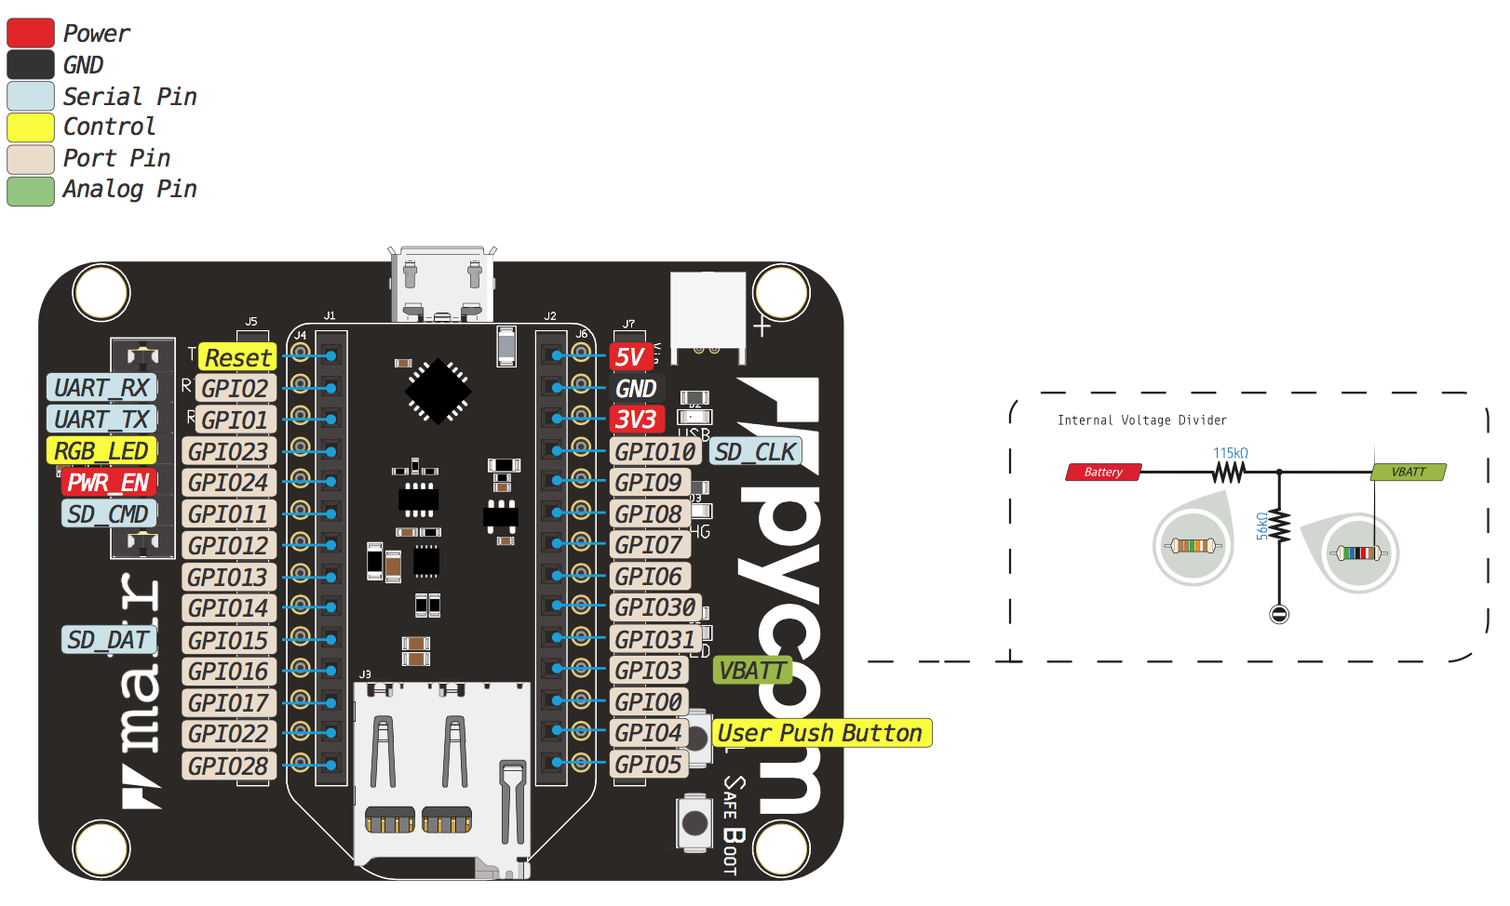
Picture 2

For a more detailed version of Picture 2, click on the following link:
https://docs.pycom.io/.gitbook/assets/expansion3-pinout.pdf

For the whole documentation of the Pycom Expansion Board 3.0, click on the following link:
https://docs.pycom.io/.gitbook/assets/expansion3-specsheet-1.pdf

WS2813 Ledstrip - 30 LED
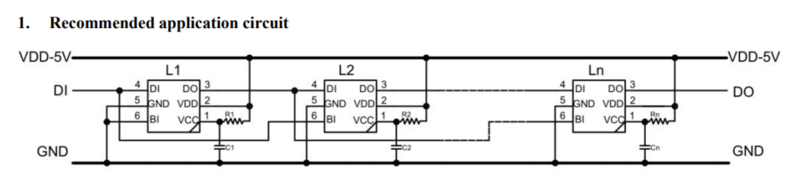
Picture 3

In Picture 3 there is a schematic of the WS2813 Ledstrip. In the following link you can find more detailed information about this ledstrip and how to program it with Arduino.
https://www.tweaking4all.nl/hardware/arduino/arduino-ws2812-led/

LTE-M Antenna
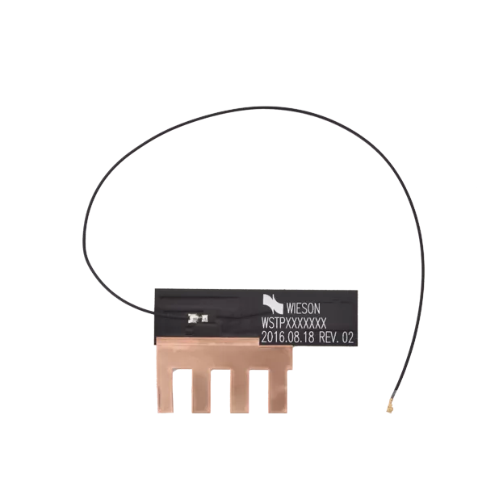

Picture 4

In the following link you can find the schematic of the LTE-M Antenna shown in Picture 4.
https://docs.pycom.io/.gitbook/assets/lte-m-antenna-drawing.pdf

I2CSoilMoistureSensor

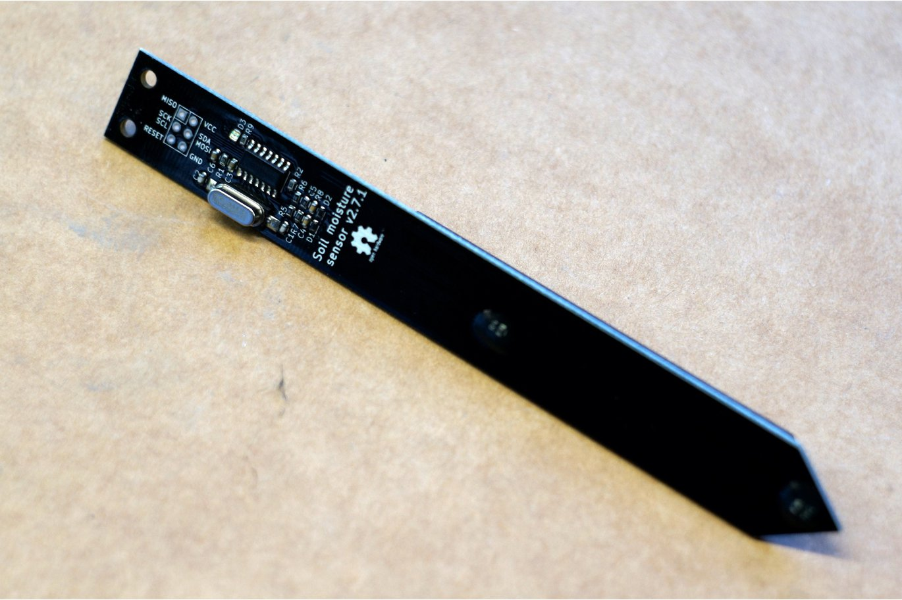

Picture 5

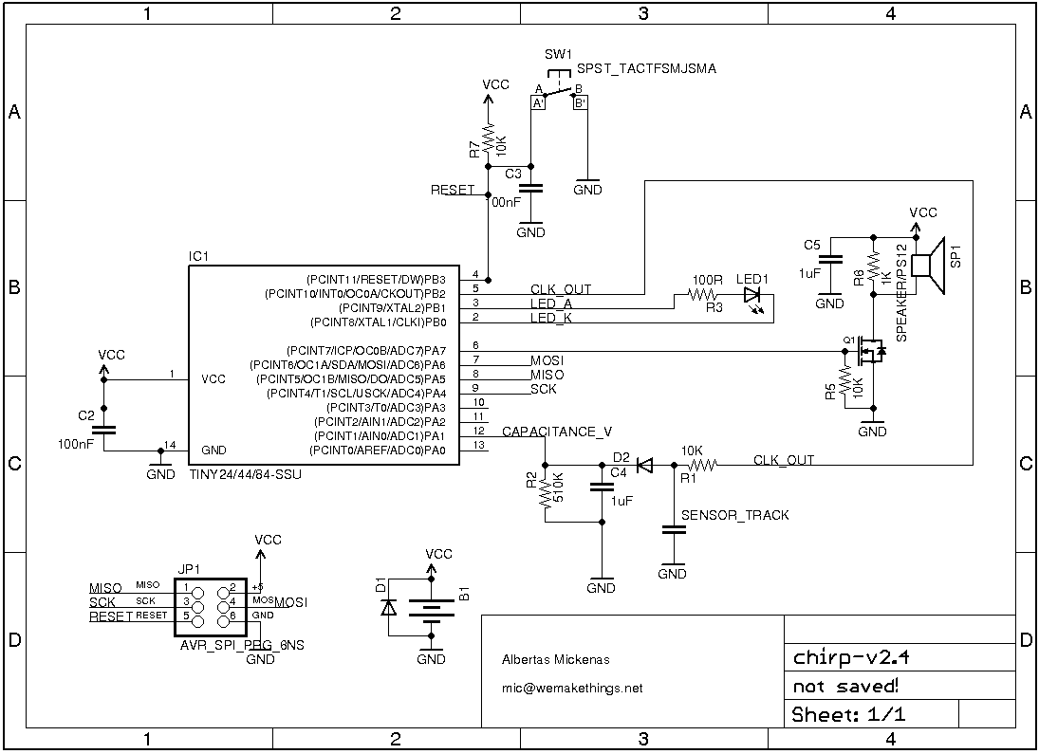
In Picture 5 you can see the I2CSoilMoistureSensor used in our project. In Picture 6 you can see the schematics of this sensor.

Source:https://github.com/Miceuz/PlantWateringAlarm/blob/master/schematics.png Picture 6
Adafruit Feather Huzzah
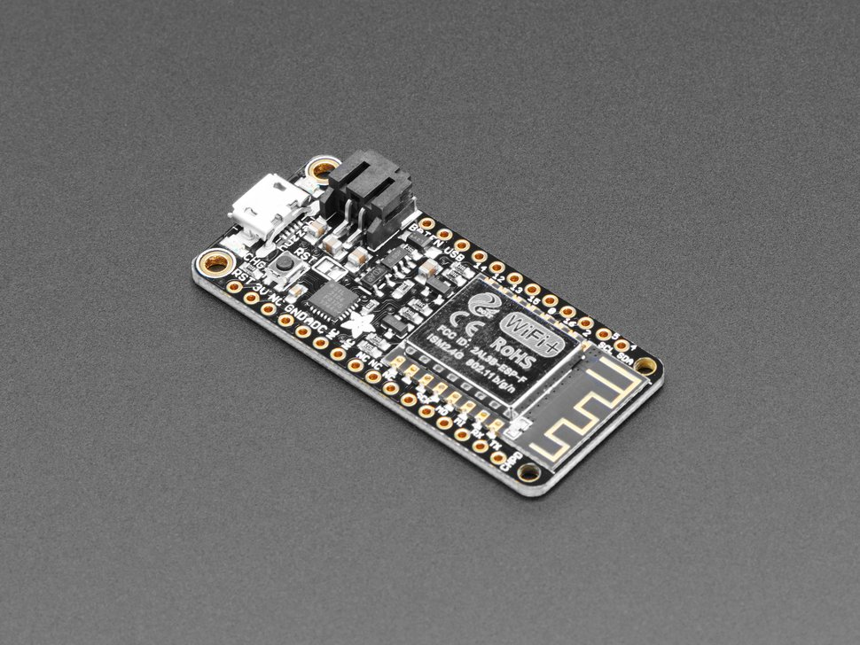
Picture 7

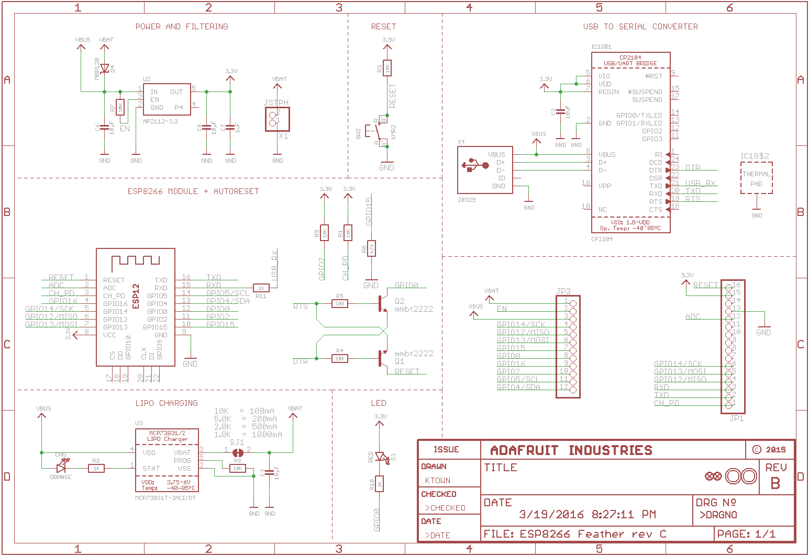
In Picture 7 you can see a picture of the Adafruit Feather Huzzah. In picture 8 there is a schematic of this chip.

Picture 8
Open the following link to see the pin layout of the Adafruit Feather Huzzah.
https://cdn-learn.adafruit.com/assets/assets/000/046/211/original/Huzzah_ESP8266_Pinout_v1.2.pdf?1504807178

Open the following link to see the full documentation of the Adafruit Feather Huzzah.
https://cdn-learn.adafruit.com/downloads/pdf/adafruit-feather-huzzah-esp8266.pdf

Lithium Ion Battery - 1Ah
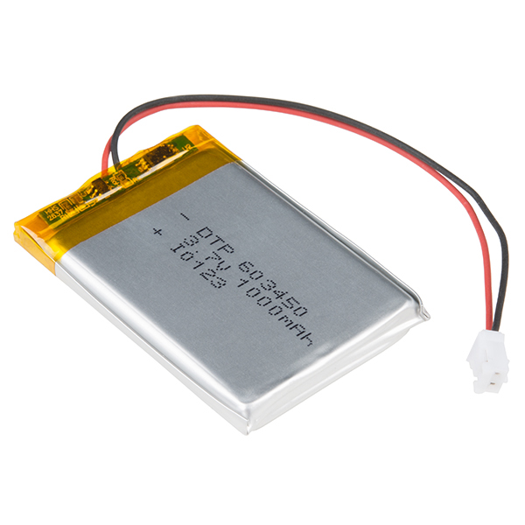

Picture 9

In picture 9 you can see the Lithium Ion Battery. In the following link you can see the documentation about the JST connector of the battery.
https://www.sparkfun.com/datasheets/Prototyping/Connectors/ePH.pdf

Open the following link to see the details about the MSDS Report of this battery.
https://cdn.sparkfun.com/datasheets/Prototyping/MSDS%20603450.pdf

